**SAD Summary**

Architecture Type = layered

1. User interface layer
2. Application logic layer
3. Database access layer

Class Diagram

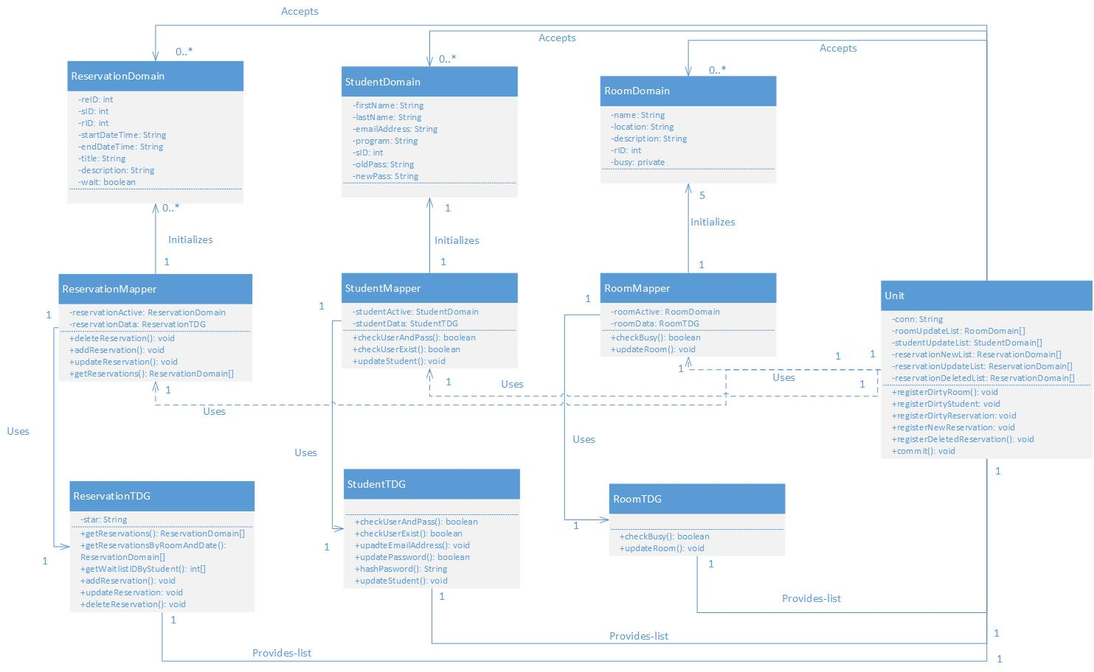

Application logic:

* Domain objects
  + ReservationDomain
  + StudentDomain
  + RoomDomain
* Mappers
  + ReservationMapper
  + StudentMapper
  + RoomMapper
* Unit of Work

Did not implement Identity Map (but neither did our team last semester, because it doesn’t work with the way PHP makes database calls)

Database access:

* TDGs
  + ReservationTDG
  + StudentTDG
  + RoomTDG

Sequence Diagrams

They made diagrams for:

* Add Reservation
* Modify Reservation
* Cancel Reservation
* Edit Profile